 ARVIN GOJAR MILAN/FRONT-END WEB DEVELOPMENT

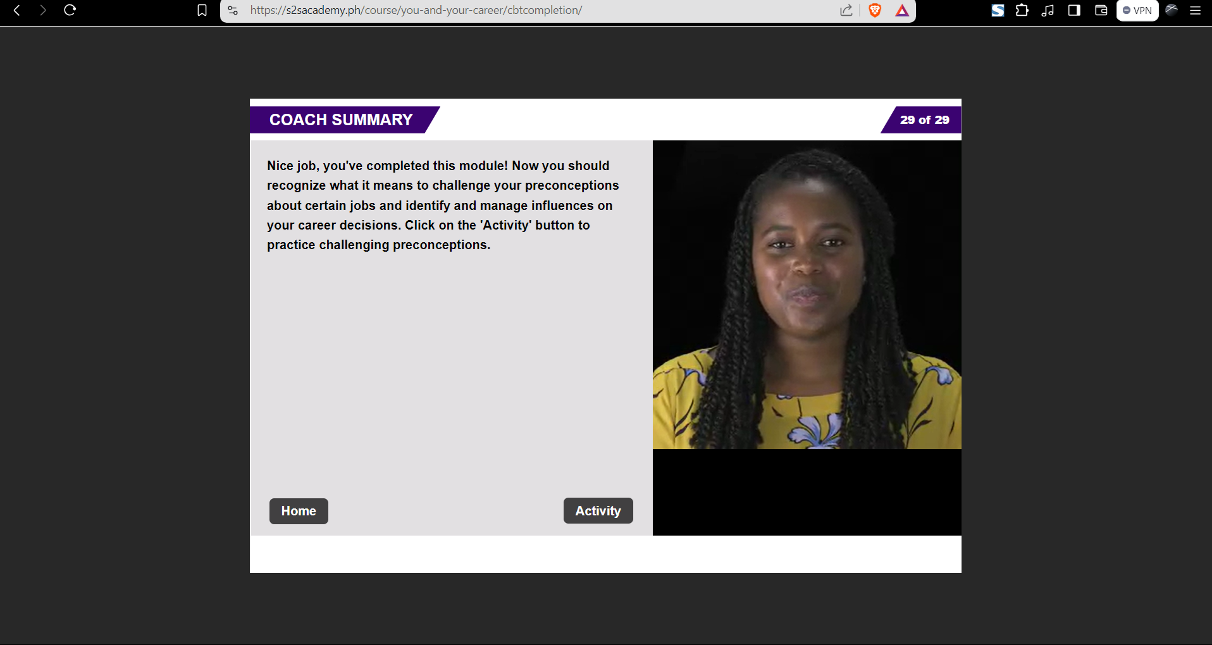

Career’s Pursuit



Lila’s Delima



Find your Future